Glider

Subject: Physics, Motion and Forces  Related Subjects: Aerospace Engineering | Grade Level(s): 9-11  Length of Lesson: 50 minutes | Type: Project  Keywords: Flight, Lift, Drag, Aerodynamics, Engineering, STEM

Lesson Overview
Students will use balsa wood to design and construct a glider. This project teaches the physics of flight and challenges students to optimize their glider for maximum distance and straight-line accuracy using engineering design principles.

Lesson Focus
What design features help a glider fly farthest and straightest? How do forces like lift, drag, gravity, and thrust interact during flight?

Lesson Objective(s) | - Understand the four forces of flight: lift, drag, thrust, and gravity.  - Apply principles of aerodynamics in a hands-on design challenge.  - Use the engineering design process to improve glider performance.

Lesson Timing

5 minutes | Introduce the Lesson
30 minutes | Design, build, and test gliders
10 minutes | Redesign and re-test
5 minutes | Wrap-up discussion and reflection

Materials | - Balsa Wood sheet  - Sandpaper  - Xacto knife  - Hot glue  - Pencil  - Paper
Instructor Prep | - Pre-cut balsa wood sheets if needed for younger students.  - Set up safe cutting and gluing stations.  - Prepare a sample glider to demonstrate flight characteristics.
Related Resources | - Balsa Glider Competition - Activity - TeachEngineering  - Paper Airplanes: Building, Testing, & Improving. Heads Up! - Activity - TeachEngineering

Lesson Plan

Introduction
Discuss how gliders fly without engines, relying on design and the forces of physics. Introduce the four forces of flight (lift, drag, thrust, gravity) and explain how each affects glider motion. Pose a challenge: “Can you design a glider that flies the farthest in a straight line?”

Procedure
- Sketch the glider design on paper, including wings, fuselage, and tail stabilizers.
- Transfer the design to balsa wood using a pencil.
- Carefully cut out each part using an Xacto knife.
- Sand edges of parts for smoother airflow.
- Assemble glider using hot glue (attach wings, tail, stabilizers).
- Allow glue to dry; make sure everything is aligned symmetrically.
- Test fly the glider in a hallway or open space.
- Observe performance and note whether adjustments are needed.
- Modify the design (e.g., adjust wing angle or tail size) and re-test.
- Reflect on changes made and how they affected flight.

Sample design:

Gravity

Thrust

Drag

Lift

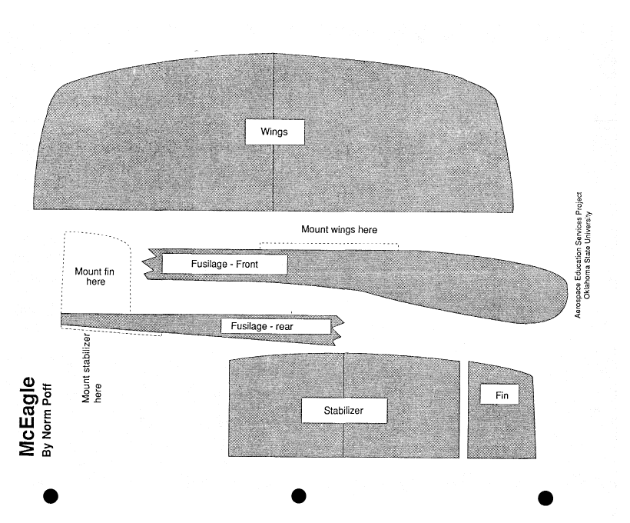

Things to consider:
- There are four principal components of flight: thrust, drag, lift and gravity.
- Wings provide lift; fins and stabilizers keep the glider straight and level by controlling yaw (left, right side to side motion), roll (left, right rotation on its side), pitch (up, down movement).

Wrap-up
Review the forces of flight and how students adjusted their gliders to balance those forces. Discuss real-world applications (e.g., airplanes, drones, satellites). Ask: What worked well? What would you improve next time?

Lesson Background for Teachers
This activity demonstrates basic aerodynamics and lets students experiment with physical design and problem-solving. Balsa Wood is ideal due to its lightweight and workable properties, mimicking real aircraft material.

Suggested Real-World STEM Connections
- Aeronautical Engineers who design aircraft and spacecraft
- Glider Pilots and professionals who work with unpowered flight
- NASA Engineers who develop UAVs (unmanned aerial vehicles)
Otto Lilienthal
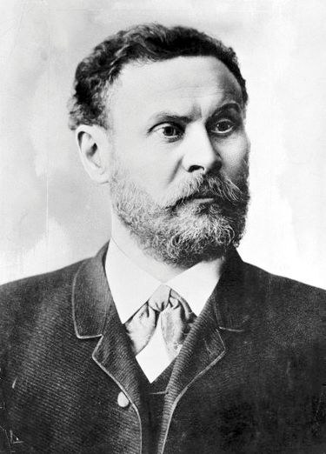
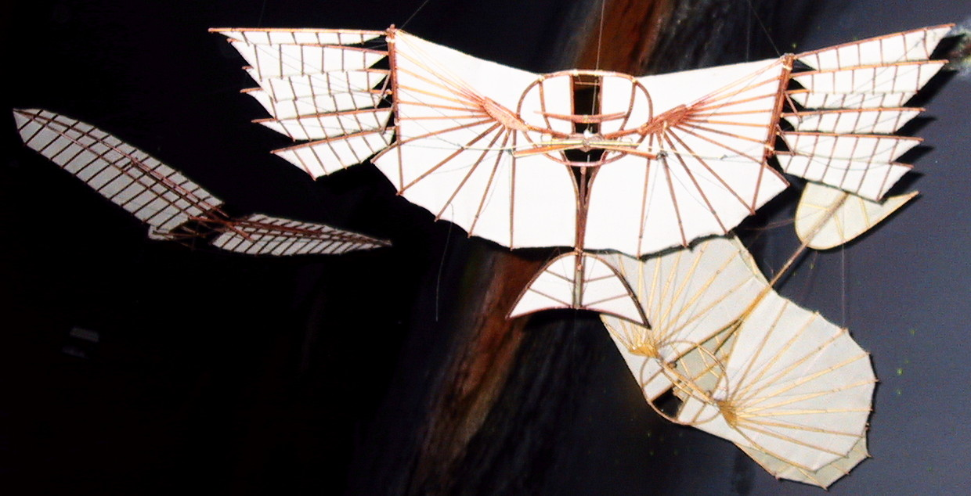
Known as the "Glider King," he was the first person to make well-documented, repeated, successful flights with unpowered gliders in the 1890s. His work laid the foundation for modern aerodynamics and inspired the Wright brothers.
Having explored the physical principles governing winged flight, Lilienthal began to design and build gliders on the basis of the information he had gathered. Between 1891 and 1896, he completed some 2,000 flights in at least 16 distinct glider types. His career as a builder and pilot of gliders coincided with the development of high-speed and stroboscopic photography.

Lesson Variations and Options
- Use cardboard or foam instead of balsa wood.
- Add weights to test how mass affects flight distance.
- Run a class-wide glider competition for furthest and most accurate flight.

Explanation
Lift is generated by air moving over the wings. Drag resists motion through the air. Gravity pulls the glider downward. Thrust (initial push) propels the glider forward. The shape, balance, and symmetry of the glider determine how these forces interact during flight.

Key Concepts and Vocabulary
- Lift: The upward force caused by air moving over wings
- Drag: Air resistance that slows the object
- Thrust: The forward force from the initial push
- Gravity: The force pulling the glider down
- Pitch, Roll, Yaw: Types of rotational motion controlled by stabilizers

Safety Notes
- Supervise all Xacto knife use—only older students or with adult help
- Use hot glue guns on a covered surface and caution with hot tips
- Be sure to launch in an open, safe area free of obstructions

